**Human Resource Information System for Department of Interior and Local Government of the Cordillera Administrative Region (DILG-CAR)**

An IT Project Proposal

Presented to the

Faculty of the School of Computing and Information Sciences

Saint Louis University

In Partial Fulfillment

of the Requirements for the Course

IT 411

by

Arvince Neil A. Alcaide

Sarah Mae E. Centino

Denver D. Culbengan

Ryan Christian A. De Guzman

Danielle Phillip A. Estrellado

Aerhielle Cassandra E. Leonen

Paul Christian C. Sam

Benedict M. Suarez

Laurence F. Balmeo

Project Adviser

December 2017

**Abstract**

Offices in general has difficulties in monitoring, tracking and updating different files and documents mostly offices that still utilizes manual processes hence requires effective information management. Information Management guarantees information can be accessed easily and let the users manipulate, track and monitor files and documents fluently. Since the Human Resource and Records Section (HRRS) under the Finance & Administrative Division (FAD) of the Department of Interior and Local Government Cordillera Administrative Region (DILG-CAR) face these difficulties in keeping manual records and managing paper-based records, the developers will create a web application that helps the management and monitoring of files and documents of the said government section.

The developers will utilize the methodology Evolutionary-exploratory Model which ensures the understanding of the requirements, the steady progress of the proposed system and the constant feedback of the client which helps the developers to produce the desired product.

The Human Resource Information System (HRIS) that will be developed for the HRRS will assist the employees in managing and tracking specifically the Personal Data Sheet (PDS), Leaves, Service Record, Notice of Step Increment (NOSI), Notice of Salary Adjustment (NOSA) and updating of Plantilla. Also, some manual processes will be computerized to maximize the effectiveness of the system.

**Table of Contents**

**ABSTRACT …………………………………………………………………………… ii**

**LIST OF FIGURES ………………………………………………………………….. v**

**LIST OF TABLES …………………………………………………………………… vii**

**CHAPTER 1: INTRODUCTION**

1.1 Context of the Study ………………………………………………………

1.2 Background of the Study …………………………………………………

1.3 Statement of the Objectives ………………………………………………

1.4 Scope of the Project ………………………………………………………

1.5 Significance of the Study …………………………………………………

1.5.1 To the Employee ……………………………………………….

1.5.2 To the HRRS ……………………….…………………………..

1.5.3 To the DILG-CAR ……………………………………………..

**CHAPTER 2: METHODOLOGY**

2.1 Requirement Gathering …………………………………………………..

2.2 Quick Design ……………………………………………………………..

2.3 Building Prototype …………………………...……………………………

2.4 Customer Evaluation ……………………………………………………..

2.5 Refactoring Prototype …………………..………………………………..

2.6 Final Product ……………………………………………………………..

2.7 Data Gathering ……………………………………………………………

2.8 Design Tools ……………………………………………………………..

2.8.1 Entity-Relationship Diagram ………………………………….

2.8.2 Relationship Database Schema ………………………………..

2.8.3 System Architecture …………………………………………. .

2.8.4 Use Case Diagram …………………………………………….

**CHAPTER 3: OUTCOMES AND RESULTS**

3.1 Requirements Specification ……………………………………………..

3.1.1 Functional Requirements ………………………………………

3.1.2 Non-Functional Requirements …………………………………

3.2 System Architecture …………………………..…………………………

3.3 Use Case Diagram ………………………………………………………

3.4 Data Architecture

3.4.1 Entity-Relationship Diagram ………………………………….

3.4.2 Data Schema …………………………………………………..

3.5 Prototypes

3.5.1 Human Resource ………………………………………………

3.5.2 Employee ………………………………………………………

3.5.3 Super User ……………………………………………………...

**REFERENCES** ……………………………………………………………..

**APPENDIX**

Appendix A. Daily Time Record ……………………………………

Appendix B. Type of Leaves ………………………………………..

Appendix C. Type of Leaves ………………………………………..

Appendix D. Application for Leave Form …………………………..

Appendix E. Computation of Leaves Credit ………………………. ..

Appendix F. Computation of Leaves Credit …………………………

Appendix G. Service Record …………………………………………

Appendix H. Notice of Step Increment ……………………………...

Appendix I. Notice of Salary Adjustment ……………………………

Appendix J. Leave Ledger Card ………………………………………

Appendix K. Personal Services Itemization and Plantilla of Personnel..

Appendix L. Personal Data Sheet ……………………………………

Appendix M. Personal Data Sheet …………………………………..

Appendix N. Personal Data Sheet …………………………………...

Appendix O. Personal Data Sheet ……………………………………

**List of Figures**

Figure 1. HRRS Organizational Chart ……………………………………………………

Figure 2. Evolutionary-Exploratory Model ………………………………………………

Figure 3. System Architecture ……………………………………………………………

Figure 4. Use Case Diagram ……………………………………………………………..

Figure 5. Entity-Relationship Diagram …………………………………………………

Figure 6. Log In …………………………………………………………………………

Figure 7. Human Resource Administrative Officer Dashboard …………………………

Figure 8. Employees Account …………………………………………………………..

Figure 9. PDS Update …………………………………………………………………..

Figure 10. PDS Update ………………………………………………………………....

Figure 11. Pending Employee …………………………………………………………..

Figure 12. Pending Employee …………………………………………………………..

Figure 13. Employee ……………………………………………………………………

Figure 14. Employee Profile ……………………………………………………………

Figure 15. Generate Report Employee …………………………………………………

Figure 16. Edit Report ………………………………………………………………….

Figure 17. Edit Report ………………………………………………………………….

Figure 18. Reports ……………………………………………………………………...

Figure 19. Reports Certificate of Employment …………………………………………

Figure 20. Reports Certificate of Employment …………………………………………

Figure 21. Pending Leave ………………………………………………………………

Figure 22. Application for Leave ………………………………………………………

Figure 23. Plantilla …………………………………………………………………….

Figure 24. Plantilla Salary Grade ………………………………………………………

Figure 25. Previous Salary Grade ………………………………………………………

Figure 26. Addition of Salary Grade ……………………………………………………

Figure 27. Plantilla Division ……………………………………………………………

Figure 28. Editing of Plantilla ………………………………………………………….

Figure 29. Plantilla Re-assign ………………………………………………………….

Figure 30. Archiving an Employee …………………………………………………….

Figure 31. Sign-up ……………………………………………………………………..

Figure 32. Employee Dashboard ………………………………………………………

Figure 33. Profile ………………………………………………………………………

Figure 34. Personal Data Sheet ………………………………………………………..

Figure 35. Edit Personal Data Sheet …………………………………………………..

Figure 36. Application Leave Form …………………………………………………..

Figure 37. Leave Summary ……………………………………………………………

Figure 38. Service Record …………………………………………………………….

Figure 39. Notification ………………………………………………………………..

Figure 40. Super User Dashboard …………………………………………………….

Figure 41. Super User Dashboard ……………………………………………………..

Figure 42. Super User Dashboard ……………………………………………………..

Figure 43. List of Employee …………………………………………………………..

Figure 44. Employee Form ……………………………………………………………

Figure 45. Employee's Personal Data Sheet ……………………………………………

Figure 46. Plantilla Division ……………………………………………………………

Figure 47. Plantilla ……………………………………………………………………..

Figure 48. Pending and Approved Leaves ……………………………………………..

Figure 49. Leave Report ……………………………………………………………….

**List of Tables**

Functional Reguirements ………………………………………………………………

**Chapter 1: Introduction**

* 1. **Context of the Study**

Human Resource Information System (HRIS) is a system used to acquire, store, manipulate, analyze, retrieve and distribute information regarding a section like Human Resources by providing ease in compiling and finding certain documents in future need within the organization (Michael J. Kavanagh and Richard D. Johnson, 2018).

In a government office, documents are considered a very essential part of their function, this includes salary records, reports, budget for the project, grievance dispute and other more. These documents are thoroughly created and processed to avoid errors. Consequently, this project focuses on Human Resource and Records Section (HRRS) of the Department of Interior and Local Government of Cordillera Administrative Region (DILG-CAR). HRRS is a section that handles the informational documents of the office which represents the memory of an organization providing tangible evidences of an organization activities and transactions, employee benefits, redeployment, termination, job description, information of employees and the likes.

DILG-CAR assists and advise the president promulgation of policies, regulation, programs and projects to promote peace and order, close general supervision for local governments, promotion of autonomy and community empowerment with a consistent monitor of compliance thereof (DILG , 2013).  Furthermore, DILG-CAR functions in organizing and training primarily for the performance of police functions, a police force that is national in scope and civilian in character. With the use of the information maintain and handheld by the HRRS it strengthens the decision making of DILG-CAR, it will support on how DILG-CAR will act with regards to the matter.

* 1. **Background of the Study**

HRRS is under the Finance and the Administrative Division (FAD) of the DILG-CAR that handles the different forms used by the regional office when it comes to their human resources. This includes the Personal Data Sheet (PDS), Daily Time Record (DTR), Service Records, Notice of Step Increment (NOSI), Notice of Salary Adjustment (NOSA), Leave Ledger Card, Application for Leave of the employee and the Personal Services Itemization and Plantilla of Personnel (PSIPOP) or Plantilla of the DILG-CAR.

DILG-CAR HRRS still uses manual processes in their current system with the use of productivity tools like Microsoft Word and Excel. Through this productivity tool they manually input the data to store it digitally for information management, it is stored in a way that each employee has different report stored in separate files. In generating the reports, they are also using the productivity tool to manually edit each report for any update or correction and it is done for every employee of DILG-CAR.

|  |
| --- |
| Finance & Administrative Division (FAD) |
| Chief Administration Officer |
| Supervising Administrative Officer |

|  |
| --- |
| Human Resource & Records Section |
| Administrative Officer V (HRMO) |
| Administrative Officer IV |
| Administrative Officer III |
| Administrative Aide IV |
| Administrative Aide IV |

*Figure 1:* HRRS Organizational Chart

The following figure *(see Figure 1)* shows the structure of the HRRS in DILG-CAR and the relations and relative ranks of their positions.

These are the current process of HRRS in DILG-CAR on their forms are the following:

1. Processing of Personal Data Sheet (PDS) (see Appendix L) – The PDS will serve as a profile of every employee in DILG-CAR. The PDS form has four (4) pages, this information contains the employee’s personal information, family background, educational background, civil service eligibility, work experience, voluntary work, training program, and other information. In figure 1, it shows the flow of how the PDS is processed. If there are information to be change or include, the employee must fill-out a new PDS form and to be submit to the HRRS. Each employee is required to update their own PDS annually before the HR Admin Officer submits the 201-Report to the Central Office. 201-Report contains all the information about an employee. As a result, the HRRS receives a large number of documents that must be check individually.

Employee

Is the information correct?

Fix the wrong information

File updated PDS

No

Yes

Store the PDS

HRRS

Figure 2

1. Processing of Employee’s Leaves Application – the DILG-CAR offers different kinds of leaves these are: Paternity Leave, Rehabilitation Leave, Terminal Leave, Special Emergency Leave, Force Leave, Sick Leave, Vacation Leave, Maternity Leave, Magna Carta for Women, Study Leave, Special Privilege Leave, Solo Parent Leave, Monetize Leave and Violence Against Women and Children Leave. Those are the kinds of leave, an employee can apply for, the process starts by manually filing a leave application. In order to be officially approved the leave application must be authorized by the HRRS, Department Officer and RD.

Employee

No

File Leave Application

No

No

Is the application is accepted by the HRRS?

Approved by the HRRS

Yes

Is the application is accepted by the officer?

Yes

Approved by the officer

Is the application is accepted by the RD?

Approved by the RD

Yes

HRRS

Figure 3

1. Processing of Employee’s Leave Credits – leave points are given to employee every first working day of the month, leave points will be consumed when an employee files an application for leave and renders the given leave, the remaining points will be computed as leave credits. Once the leave credits are not used it will accumulate and will be converted into cash once the employee files a resignation letter. If an employee files a sick leave and the employee does not have enough leave credits, the employee is allowed to borrow leave credits from vacation leave credit, but not vice versa. If there are no left leave credits left in the employee’s vacation leave, it will be deducted to the employee’s salary. The computation of leave credits is done manually by the HR Admin Officer. It is stored in a spreadsheet file entitled Leave Ledger Card (see Appendix J), it is the form where the points of every employee of the DILG-CAR is stored. In computing leave credits HR Admin Officer needs to refer to the following forms which are the DTR and Leave Form of each employee.

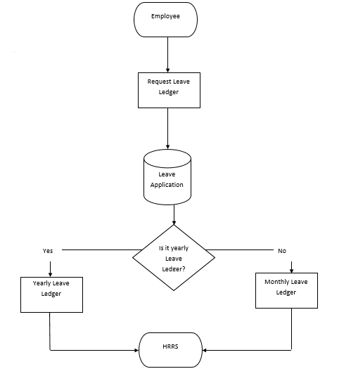

Figure 4

4. Updating of the Plantilla – The Plantilla (see Appendix K) is being released by the Department of Budget and Management (DBM) every start of the year and will be use by the HR Admin Officer all throughout the year. Afterwards the HR Admin Officer will send an updated version of the Plantilla to the DBM every end of the year for documenting purposes. The Plantilla is a form that monitors the employee status in the DILG-CAR, it is a form that holds the entire population of DILG-CAR. Every time an individual employee is either promoted or re-assigned, the Plantilla will be the first to be updated. If there are changes within Plantilla, it will be reflected on the reports connected in the Plantilla such as the PDS and Service Record. Changes made in the Plantilla are done manually using a spreadsheet. The HR Admin Officer often uses the cut and paste method to obtain the information of a certain employee in the Plantilla, this is done to transfer the employee’s information to the designated vacant position in the Plantilla. By using spreadsheet to do the process of promoting and re-assigning makes a lot of work because in every Division of the Plantilla needs different spreadsheet files. When an update occurs the HR Admin also needs to manually update the forms related to the Plantilla. The updated version of the Plantilla will be submitted by the HR Admin Officer to the DBM through the Government Manpower Information Systems (GMIS) official website.

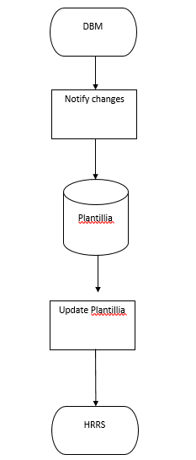

Figure 5

5. Processing of Employee’s Service Record, NOSI and NOSA– Service Record serves as a summary of the whole working experience of a government employee in the DILG-CAR. This form can be requested by the employee to be provided by the HR Admin Officer, it will be done by using word processing tools. The Service Record is stored in a way that each employee of DILG-CAR has its own word processing file entitled to the employee’s name. Data from the Service Record is acquired from the Plantilla, which means that if the employee is promoted or reassigned in Plantilla the Service Record of that employee is to be updated as well. The release of NOSA or NOSI is another factor of updating the Service Record. Updating forms of DILG-CAR will be difficult because of the probability that a change in the Plantilla may affect the information with regards to the forms that is connected to another form making the whole process complicated. NOSA is Notice of Salary Adjustment and NOSI is Notice of Step Increment. The two (2) forms will serve as a proof of adjustment or increase on the salary of every employee of DILG-CAR. While NOSA is released by the government to inform every employee regarding their salary adjustment, it will only happen once the National Budget Circular of the DBM order for salary adjustment. The NOSA is given by DBM to the HR Admin Officer and will be given to each employee. NOSI will be given when an employee is qualified for a promotion or an employee completed a three (3) years of working service on the same position. Salary Grade is a table that contains the different levels of salary an employee can have, starting from salary grade 1 to salary grade 28. This two (2) forms are produced via a word processing tool, the DBM will produce a template and the HR Admin Officer will edit this form manually for every

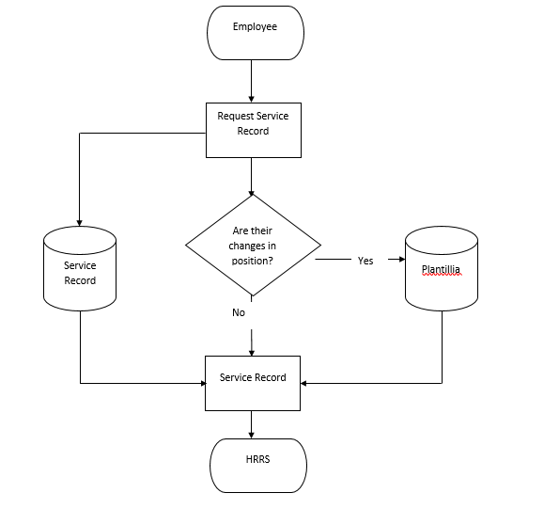

Figure 6

HRRS

Notify changes

Plantillia

Is their increment in salary?

No

Yes

Employee

NOSA

NOSI

Figure 7

* 1. **Statement of the Problems**

1. The information that the employees are entering in their PDS is not always accurate.

2. The employees who attend seminars and trainings are difficult to monitor due to their outdated PDS.

3. The employees who leave on the different days and currently on their leaves are difficult to monitor.

4. The HRRS uses a Microsoft Excel to have the computation of every employee's leave credits.

5. The HRRS uses a Microsoft Excel to monitor the Plantilla and they use copy and paste method to have a history of their Plantilla.

6. In generating every employee's Service Record, NOSI and NOSA typographical error is a common error that they are encountering.

This is the proposal that HRIS will performed in the HRRS of the DILG-CAR are the following:

The system will be a web application that employee’s and the HRRS can be access from the office. The system will have a log in system to secure the information of the employee and the HRRS. The new user will have to input the first part of the PDS which is the personal information section. The main processes of our system are to view, edit, and generate the following:

1. PDS – in the system, the process of the PDS is almost similar with the current process of DILG-CAR except in the system the process is computerized and doesn’t have to be print. The PDS in the system can be viewed and edit by the employee anytime there is an update in their PDS and can be print if needed. The HRRS can now easily check the update of their PDS.
2. Leave Application – there will be a template for the application which an employee can fill up and print afterwards, then submit the printed file to the HRRS. After the HRRS checked the form, it will be delivered to the employee’s department head then to the RD to be approved. If approved by both then it will be mark in the system approved. This will help the HRRS to monitor the leave of their employee.
3. Leave Ledger – the system can query some information of the employee to create their leave ledger.
4. Plantilla – the plantilla can be edit, view and generate for the HR admin Officer. The plantilla in the system will have a function of promoting and re-assigning a certain employee and can archive employee too.
5. Service Record – some of the data will be query from the service experience in the PDS and the update will come from the Plantilla.
6. NOSI and NOSA – there will be templates for NOSI and NOSA in the system and certain data’s can be query to supply some information
   1. **Statement of the Objectives**

The Objective of the project is to develop a HRIS to automate manual working related processes between Employee and the Human Resource Administrator, and improve monitoring and checking of processes by the Human Resource for DILG-CAR.

* To collect and determine the requirements by gathering data that is significant in the development of the HRIS System
* To establish this different architecture and models in designing the system which are the Application and System Architecture, Entity Relationship Diagram and Data Schema
* To implement the design by using different tools and technologies.
* To present the system functions and feature through performing beta testing with different user.
* To maintain and deployment the system.
  1. **Scope of the Project**

The proposal of this project is to improve the system of the HRRS in the DILG-CAR. The developers conducted a requirement elicitation and analysis of the current condition of the regional office of DILG-CAR to collect data needed for the functional requirements of the HRIS for DILG-CAR and the following processes are observed as follows; processing of Personal Data Sheet, processing of employee's work time, processing of employee's leaves, processing of employee's leave credits, maintaining of the Plantilla, processing of employee's Service Record, NOSI, and NOSA. The propose system will not include the Daily Time Record of the employee.

* 1. **Significance of Study**

**1.6.1 To the Employee**

It would help the employees conveniently do work transactions. The process of viewing and updating their own PDS will be faster. Filling leave application become easier. Generating different forms are directly from the system.

**1.6.2 To the HRRS**

It would help the human resource personnel facilitate all the transactions more effective. It would also gather and track personal information easier to prevent from duplication. All forms are also connected to each other, if changes occur then it will update the other forms.

**1.6.3 To the DILG-CAR**

It would help the DILG-CAR reach employees and make their work more accessible. It will also be helpful in keeping track all the employee’s information and monitor all their work transactions.

**CHAPTER 2**

**Methodology**

The methodology that the developers will use for the development of the system is the Evolutionary-Exploratory Model. With requirements that is constantly changing throughout the development of the system using the model is suitable for the project. By using this model, the developers will be able to understand much better the process and purpose of each part in different forms of the HRRS to make development more effective. Through analyzing the gathered data, frequent interviews with the HRRS and observing the current process the developers narrow down the essential requirements, and create features and modules. The developers design a diagram to explain the phases for the development of the system.

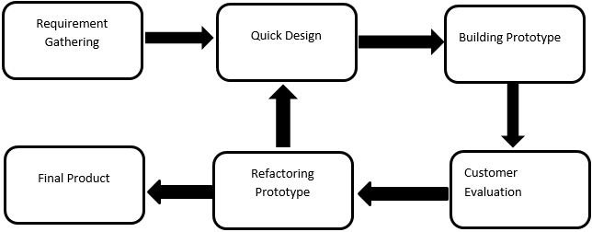

Figure 8

With the phases of the model the developers are improving and making changes with every iteration that is being made thus achieving the desired final product.

**2.1 Requirement Gathering**

In the requirement gathering phase allow the developers to identify processes of the HRRS in DILG – CAR. The information of each process must be identified, situation where problems occur, different forms with their respective procedure and other information that are necessary to understand by the developers. Document analysis, data gathering, observation of process and interview are the source of information that will be use by the developers for the project.

**2.1.1 Data Gathering**

The methods that the developers will use in gathering information are interviews, studying the HRRS current process, analyzed different forms and documents.

The developers will be observing the working area of the HRRS to understand the different processes that is taking place in the working area. The developers interviewed the Administrative Officer of the HRRS by asking questions like the step by step process of different forms, problems and concerns occur in the office, explanation of different forms relate to other forms, and how the system should process and the outcome of the forms generate by the system. The developers asked the HRRS to recite the documents needed to managed the processes and the generated reports after the process. Sample copies of reports and user records were also collected so that the developers may have a very good understanding about the content and the processes of the client’s work.

The developers see the website ELOPDS. This will be the base appearance of the system suggested by the RITCTU. It shows the sign-up, sign-in, view table, edit form, and other functions of their website. The RITCTU also give the theme for the system following the color of the logo of DILG.

**2.2 Quick Design**

In the quick design phase, the developers create design the back-end and the front-end of the system. This design is base from the requirements that will be gather in the requirement phase and the requirement or suggestion of the HRRS.

**2.2.1 Design Tools**

**2.2.1.1 Entity-Relationship Diagram**

The Entity-Relationship diagram will be use by the developers to represent the information system for DILG’s daily monitoring of work and to show the relationships between entities in the database.

**2.2.1.2 Relationship Database Schema**

This will support the ERD used by the developers, it will describe the data or information that is stored in the database. The schema represents the view of the entire database including its constraint to specify the rules for data in a table.

**2.2.1.3 System Architecture**

Application Architecture will be use in the development of the system to define the framework and structure of the organization’s application. It establishes the framework for agility, reliability and scalability in the application system so that the application will respond effectively and efficiently to changes in the important information systems. And it defines the necessary application systems to process data and support solutions for the business requirements. It also shows how this application communicate with each other and to its users.

**2.2.1.4 Use Case Diagram**

Use Case Diagram will be use in the development of the system to depict the interactions among the elements of the system and to developers to identify, clarify and organize system requirements.

**2.3 Building Prototype**

The prototype phase is the start of development of the quick design that is created by the developers. The developers will develop the prototype based on the current requirements and data gathered. The developers work both front-end and the back-end of the system.

**2.4 Customer Evaluation**

The client evaluation phase is where the client evaluates the system created by the developers. The person who will evaluate are from the HRRS or Regional Information & Communication Technology Unit (RITCTU) of the DILG-CAR. The data will be form of all possible data that can be test and wrong data given by the HRRS. The first input right data and follow the correct instruction then after the whole process is the wrong data will be input and a scenario where mistake happen to see the result for both right and wrong situation. The client will give the developers feedback about the system. It will be 20 minutes of explaining the progress of the system, 30 minutes or 1 hour and 30 minutes of testing of data input in the system and 10 minutes of recording of results of the evaluation. It will be 1 times a week when both developers and client is free.

**2.5 Refactoring Prototype**

The refactoring prototype phase is where the developers’ refractors or update the system from the feedback of the client. After the client do the evaluation, if the client sees problems, a system error occurs or the client wants minor changes in the system or in some cases the developers found bugs then the developers will list it. Then the developers will fix the problem and the bug, and then updated system to present it to the client.

**2.6 Final Product**

After all the building of prototype, evaluation, and refactoring to attain the system required, the final product phase will start. In this phase, the developers will present it to the whole employee of the DILG – CAR main office to demonstrates it to them so that they know how to use the system. The developers also make a manual of the system to help the employees and the HRRS how to use the system.

2.7 Timeline of the system

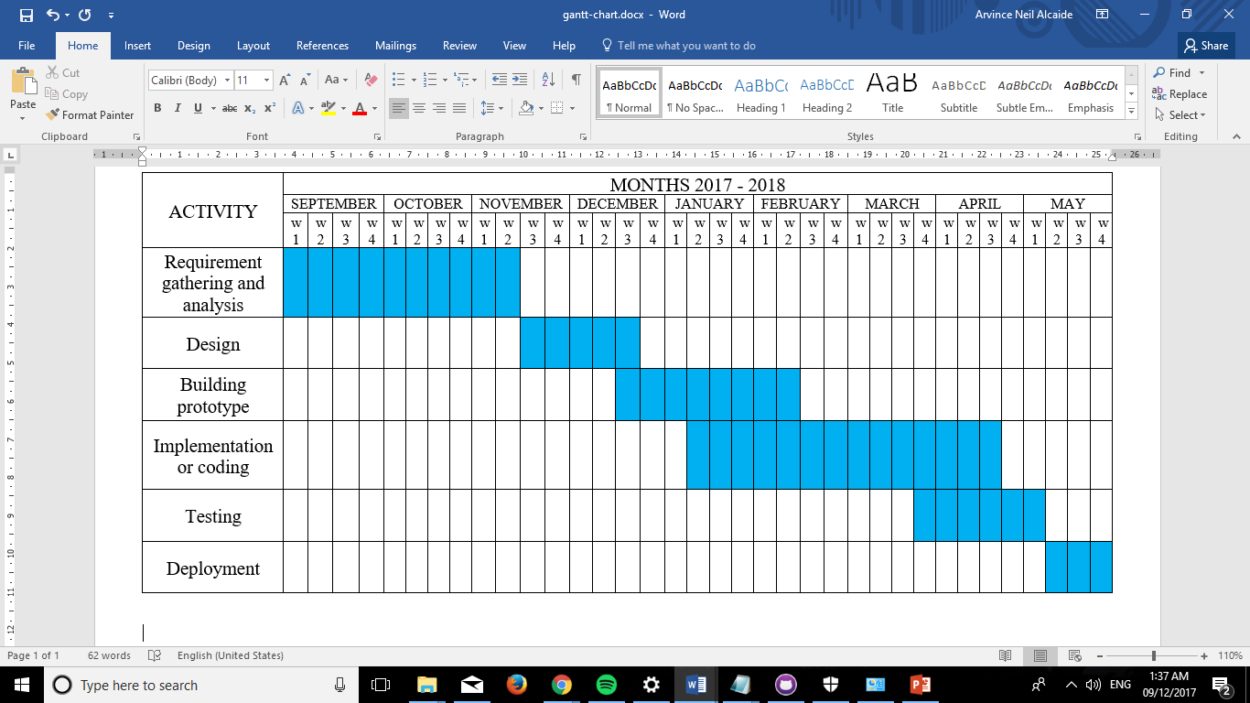

Figure 9

**Chapter 3: Outcomes and Results**

**3.1 Requirements Specification**

Table 1: The following are the list of functional requirements provided by the system.

|  |  |
| --- | --- |
| Employee | * Will be able to modify their personal information in the PDS * Will be able to view their PDS * Will be able to update their PDS * Will be able to input their leave information * Will be able to file their leave application * Will be able to modify their leave information * Will be able to view their leave information * Will be able to update their leave information * Will be able to view their Service Record |
| HR Admin Officer | * Will be able to generate the PDF file of PDS * Will be able to input data in the Leave Ledger * Will be able to modify leave ledger of employee * Will be able to view the pending and approve leaves * Will be able to view the Leave Ledger of employee * Will be able update the Leave Ledger of employee * Will be able to accept or reject employee’s file leave * Will be able to print Leave Ledger * Will be able to input data in the Service Record * Will be able to modify the Service Record of employee * Will be able to view the Service Record of employee * Will be able update the Service Record of employee * Will be able to print Service Record * Will be able to input data in the Plantilla * Will be able to modify personal information in the Plantilla * Will be able to view the Plantilla * Will be able to update the Plantilla * Will be able to select employee to promote, re-assign, or archive in the Plantilla * Will be able to print Plantilla * Will be able to modify the NOSI of employee * Will be able to view the NOSI of employee * Will be able update the NOSI of employee * Will be able to print the NOSI * Will be able to modify the NOSA of employee * Will be able to view the NOSA of employee * Will be able update the NOSA of employee * Will be able to print the NOSA * Will be able to view the Certificate of Employment of employee * Will be able to print Certificate of Employment of employee * Will be able to search specific employee profile * Will be able to search, view and filter pending employees * Will be able to select a report to generate |
| Regional Director | * Will be able to view the PDS of employee * Will be able to view the Leave Ledger * Will be able to view the Plantilla * Will be able to view the Service Record * Will be able to view pending and approved leaves |

**3.1.2 Non-Functional Requirements**

The following are the list of how the system should be:

* The system must be able to secure privacy of information
* The performance of the system should be fast; there should be no run-time constraints
* The system should provide accurate and precise data
* The system should be easy to operate and learn
* The system should be able to handle error detection and checking of duplicates
* The system should be able to handle capacity of resources and data to be processed

**3.2 System Architecture**

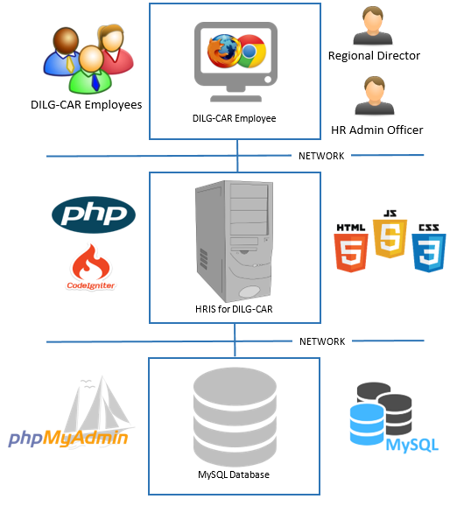

Figure 10: System Architecture for HRIS of DILG-CAR

**3.3 Use Case Diagram / Site Map / Function Models**

**3.4 Data Architecture**

**3.4.1 Entity-Relationship Diagram**

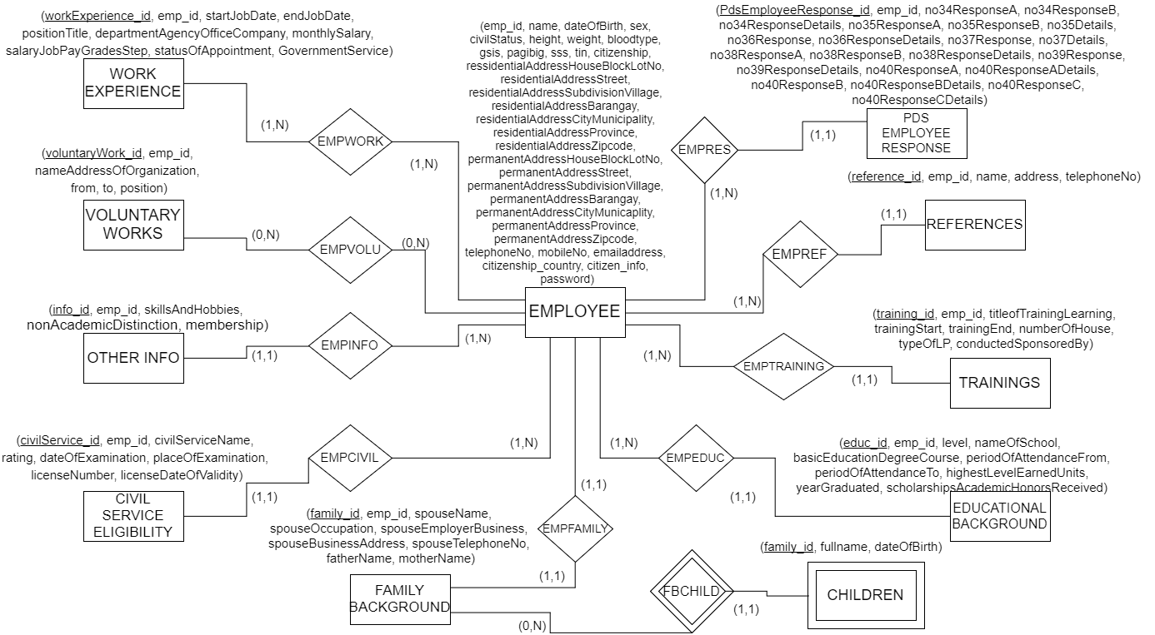

Figure 11

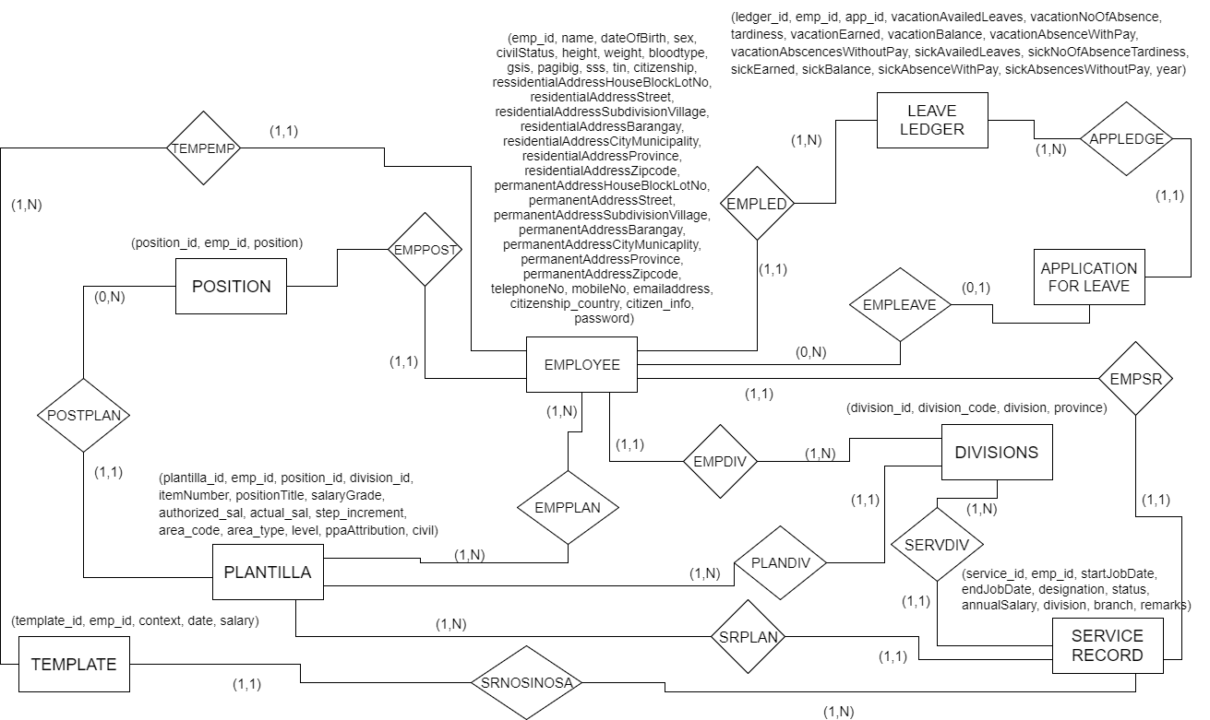

Figure 12

**3.4.2 Data Schema**

APPLICATION FOR LEAVE (app_id, emp_id, typeOfLeave, location, sickInfo, noOfWorkingDays, inclusiveDates, status)

FK emp_id References Employee Nulls Not Allowed

Delete Cascade, Update Cascade

AK emp_id

CIVILSERVICE ELIGIBILITY (civilService_id, emp_id, civilServiceName, rating, dateOfExamination, placeOfExamination, licenseNumber, licenseDateOfValidity)

FK emp_id References Employee Nulls Not Allowed

Delete Cascade, Update Cascade

CHILDREN (family_id, fullname, dateOfBirth)

FK family_id References FamilyBackground Nulls Not Allowed

Delete Cascade, Update Cascade

DIVISION (division_id, division_code, division, province)

AK division_code

EDUCATIONAL BACKGROUND (educ_id, emp_id, level, nameOfSchool, basicEducationDegreeCourse, periodOfAttendanceFrom, periodOfAttendanceTo, highestLevelEarnedUnits, yearGraduated, scholarshipsAcademicHonorsReceived)

FK emp_id References Employee Nulls Not Allowed

Delete Cascade, Update Cascade

EMPLOYEE (emp_id, name, dateOfBirth, sex, civilStatus, height, weight, bloodtype, gsis, pagibig, sss, tin, citizenship, ressidentialAddressHouseBlockLotNo, residentialAddressStreet, residentialAddressSubdivisionVillage, residentialAddressBarangay, residentialAddressCityMunicipality, residentialAddressProvince, residentialAddressZipcode, permanentAddressHouseBlockLotNo, permanentAddressStreet, permanentAddressSubdivisionVillage, permanentAddressBarangay, permanentAddressCityMunicaplity, permanentAddressProvince, permanentAddressZipcode, telephoneNo, mobileNo, emailaddress, citizenship_country, citizen_info, password)

AK name

EMPVOLU (voluntaryWork_id, emp_id, position_title)

FK voluntaryWork_id References Voluntary Works Nulls Not Allowed

Delete Cascade, Update Cascade

FK emp_id References Employee Nulls Not Allowed

Delete Cascade, Update Cascade

EMPWORK (workExperience_id, emp_id, year)

FK workExperience_id References Work Experience Nulls Not Allowed

Delete Cascade, Update Cascade

FK emp_id References Employee Nulls Not Allowed

Delete Cascade, Update Cascade

FAMILY BACKGROUND (family_id, emp_id, spouseName, spouseOccupation, spouseEmployerBusiness, spouseBusinessAddress, spouseTelephoneNo, fatherName, motherName)

FK emp_id References Employee Nulls Not Allowed

Delete Cascade, Update Cascade

LEAVE LEDGER (ledger_id, emp_id, app_id, vacationAvailedLeaves, vacationNoOfAbsence, tardiness, vacationEarned, vacationBalance, vacationAbsenceWithPay, vacationAbscencesWithoutPay, sickAvailedLeaves, sickNoOfAbsenceTardiness, sickEarned, sickBalance, sickAbsenceWithPay, sickAbsencesWithoutPay, year)

FK emp_id References Employee Nulls Not Allowed

Delete Cascade, Update Cascade

FK app_id References ApplicationForLeave Nulls Not Allowed

Delete Cascade, Update Cascade

AK emp_id

OTHER INFO (info_id, emp_id, skillsAndHobbies, nonAcademicDistinction, membership)

FK emp_id References Employee Nulls Not Allowed

Delete Cascade, Update Cascade

PLANTILLA (plantilla_id, emp_id, position_id, division_id, itemNumber, positionTitle, salaryGrade, authorized_sal, actual_sal, step_increment, area_code, area_type, level, ppaAttribution, civil)

FK emp_id References Employee Nulls Not Allowed

Delete Cascade, Update Cascade

FK position_id References Position Nulls Not Allowed

Delete Cascade, Update Cascade

FK division_id References Division Nulls Not Allowed

Delete Cascade, Update Cascade

AK emp_id

PDS EMPLOYEE RESPONSE (PdsEmployeeResponse_id, emp_id, no34ResponseA, no34ResponseB, no34ResponseDetails, no35ResponseA, no35ResponseB, no35Details, no36Response, no36ResponseDetails, no37Response, no37Details, no38ResponseA, no38ResponseB, no38ResponseDetails, no39Response, no39ResponseDetails, no40ResponseA, no40ResponseADetails, no40ResponseB, no40ResponseBDetails, no40ResponseC, no40ResponseCDetails)

FK emp_id References Employee Nulls Not Allowed

Delete Cascade, Update Cascade

POSITION (position_id, emp_id, position)

FK emp_id References Employee Nulls Not Allowed

Delete Cascade, Update Cascade

REFERENCES (reference_id, emp_id, name, address, telephoneNo)

FK emp_id References Employee Nulls Not Allowed

Delete Cascade, Update Cascade

SERVICE RECORD (service_id, emp_id, startJobDate, endJobDate, designation, status, annualSalary, division, branch, remarks)

FK emp_id References Employee Nulls Not Allowed

Delete Cascade, Update Cascade

AK emp_id

TEMPLATE (template_id, emp_id, context, date, salary)

FK emp_id References Employee Nulls Not Allowed

TRAININGS (training_id, emp_id, titleofTrainingLearning, trainingStart, trainingEnd, numberOfHouse, typeOfLP, conductedSponsoredBy)

FK emp_id References Employee Nulls Not Allowed

Delete Cascade, Update Cascade

VOLUNTARY WORKS (voluntaryWork_id, emp_id, nameAddressOfOrganization, from, to, position)

FK emp_id References Employee Nulls Not Allowed

Delete Cascade, Update Cascade

WORK EXPERIENCE (workExperience_id, emp_id, startJobDate, endJobDate, positionTitle, departmentAgencyOfficeCompany, monthlySalary, salaryJobPayGradesStep, statusOfAppointment, GovernmentService)

FK emp_id References Employee Nulls Not Allowed

Delete Cascade, Update Cascade

**3.5 Prototypes**

**3.5.1 Human Resource Administrative Officer**

**3.5.2 Employee**

**3.5.3 Super User**

**APPENDIX**

**Appendix A:** Daily Time Record

**Appendix B:** Type of Leaves

**Appendix C:** Type of Leaves

**Appendix D:** Application for Leave Form

**Appendix E:** Computation of Leaves Credit

**Appendix F:** Computation of Leaves Credit

**Appendix G:** Service Record

**Appendix H:** Notice of Step Increment

**Appendix I:** Notice of Salary Adjustment

**Appendix J:** Leave Ledger Card

**Appendix K:** Personal Services Itemization and Plantilla of Personnel (Plantilla)

**Appendix L:** Personal Data Sheet

**REFERENCES:**

[1] Human Resources Technology Council (U.S.) and United States Office of Personnel Management. (1997). *Governmentwide human resources information systems study*. Retrieved from

http://www.worldcat.org/title/governmentwide-human-resources-information-systems-study/oclc/38530163&referer=brief_results

[2] Michael J. Kavanagh and Richard D. Johnson. (2014, January 14). *Human Resource Information Systems: Basics, Applications, and Future Directions (4th. ed.)*. Retrieved from

https://books.google.com.ph/books?id=3TxbDgAAQBAJ&pg=PA1&source=gbs_toc_r&cad=2#v=onepage&q&f=false

[3] DILG. (2013). *DEPARTMENT OF INTERIOR AND LOCAL GOVERNMENT: Powers & Functions*. Retrieved from<http://www.dilg.gov.ph/page/Powers-Functions/21>

[4] ISO. *International Organization for Standardization 15489-1:2016: Information and documentation -- Records management -- Part 1: Concepts and principles*. Retrieved from <https://www.iso.org/standard/62542.html>

[5] Rouse, M., Gibilisco, S. (2015, January). *use case diagram (UML use case diagram)*. Retrieved from http://whatis.techtarget.com/definition/use-case-diagram